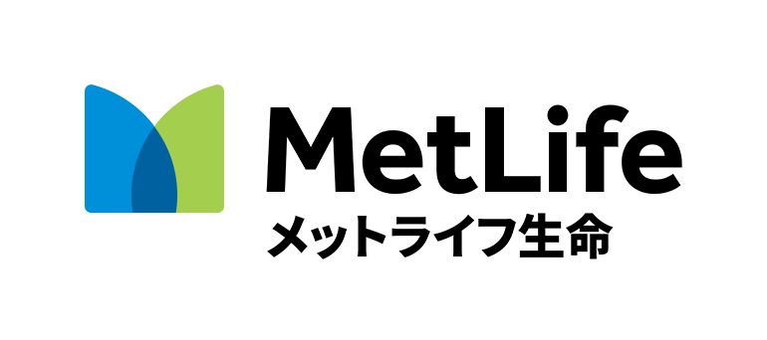

TOMODACHI MetLife Women’s Leadership Program

Mentee (Student) Application Form
Program City you are applying for (Tokyo, Osaka, Naha, or Fukuoka)
Please provide the name of any other TOMODACHI programs you are currently participating in or applying for.
Please provide the name of any TOMODACHI programs you have participated in in the past.
Last Name | First Name | Date of Birth (MM/DD/YEAR)
University | Major | Grade (1st, 2nd, or 3rd year)
Email Address |  | Phone number
Mailing address (including ZIP code)

If you have ever studied or lived abroad, please describe your experience.
What are your hobbies and personal interests?
Please tell us about a situation where you demonstrated your leadership skills. What did you learn from the experience? What were the results? Please write a response (in English) in 100 words or less.
Please describe what you expect from this program and/or how you plan to contribute to society (future career plan) after this program. Please write a response (in English) in 100 words or less.
Please submit your applications via email by June 26, 2017 to your local TMWLP office (see below):
Tokyo Area: Submit applications to: TokyoTMWLP@usjapancouncil.org
Osaka Area: Submit applications to: KansaiTMWLP@usjapancouncil.org
Fukuoka Area: Submit applications to: KyushuTMWLP@usjapancouncil.org
Naha Area: Submit applications to: OkinawaTMWLP@usjapancouncil.org
The results will be announced by August 14, 2017.

