2021 SNU-KYUSHU KOR-JPN CULTURAL EXCHANGE VIDEO CONTEST
[Form 1] Application Form & Storyboard
2021 SNU-KYUSHU KOR-JPN CULTURAL EXCHANGE VIDEO CONTEST
Application Form
Theme  (select one) | □ Popular Music □ Dining Culture □ College Life
Participants | # | Name | Student ID. | Year | Department, College/School
 | 1
 | 2
 | 3
Main  contact person | Name |  | Email Address |  |  | Cell Phone
Title of the video
Introduction of the video

Notice:
- Seoul National University and Kyushu University will have the right to post the content submissions on the university official websites or SNS accounts.
- Any legal issues concerning portrait rights or copyright violations arising from a content submission is solely the legal responsibility of the contestant.

SCENE  NO. | PICTURE | DIALOGUE | NOTES
1
2
3
4

(Storyboard Sample↓)
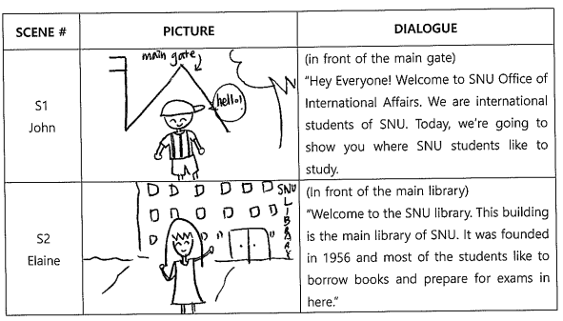
Attachment: Consent to Collection, Use and Disclosure of Personal Information
Attachment
Consent to Collection, Use and Disclosure of Personal Information

Task : 2021 SNU-KYUSHU KOR-JPN CULTURAL EXCHANGE VIDEO CONTEST

1. Regarding the task above in connection with 2021 SNU-KYUSHU KOR-JPN CULTURAL EXCHANGE VIDEO CONTEST I hereby agree with Seoul National University and Kyushu University upon collection, use or limitation of my personal information described below.

1) Collection and Use

- Candidate selection, evaluation and management including video submission and winner selection
- Other items considered as necessary for the video contest
- Follow-ups such as students’ participation in 2022 student exchange program.

2) Information to Be Collected

Name, student ID, email address, phone number, affiliated department/college or school, gender

3) Limitation of Using the Information
Personal information collected for 2021 SNU-KYUSHU KOR-JPN CULTURAL EXCHANGE VIDEO CONTEST will be only limited to the project and task concerned and will not be used for other projects or provided to a third party.

2. I hereby agree that Seoul National University and Kyushu University will maintain my personal information from the day when I signed this Consent to the day when the purpose of collection, use and limitation of the information described 1.1) served fully.

(Applicant 1) Date: 31 March 2021, (Signature)
(Applicant 2) Date: 31 March 2021, (Signature)
(Applicant 3) Date: 31 March 2021, (Signature)

* You may refuse to consent to your personal information being collected/used. However, this personal information is essential for execution of the contest, and so if you refuse to consent, you may not be able to participate in the contest.
** If you have any feedback and concerns regarding the processing of your personal data, please contact your program coordinator at KU International Student Exchange Division.

Kyushu University International Student Exchange Division

